Dale Smallwood 130089872

Business Systems Modelling Assignment 1

Contents

Table of Figures 2

Introduction 3

Company overview 4

what is a data flow diagram? 4

Online ordering 5

Data flow diagram for online order 6

Ordering by Phone 7

Data flow diagram on phone ordering 8

Instore ordering 9

Data flow diagram of in-store ordering 10

Importance of system modelling 11

Activity diagrams 11

Use case diagrams 11

Sequence diagrams 11

State diagrams 11

Reduction of waste 12

Efficiency 12

what is a Crud analysis? 12

Crud analysis of Rotherham kebabs 12

Normalization 13

What are Entity relationship diagrams? 14

Doncaster DIY 15

Online 15

Phone Call 16

In-Store 16

Bibliography 17

Appendix/Appendices 18

# Table of Figures

Figure 1 Manager Loop 5

Figure 2 DFD of Online Ordering 6

Figure 3 State machine online order system 6

Figure 4 On-Phone Improvement 7

Figure 5 on Phone DFD 8

Figure 6 In shop DFD 10

Figure 7 Rotherham Kebabs CRUD 12

Figure 8 Example of redundancy 13

Figure 9 LucidChart (2020) [ERD Cardinality] https://www.lucidchart.com/pages/ER-diagram-symbols-and-meaning 14

Figure 10 Entity Relationship Online Order System 14

Figure 11 Activity Diagram 15

# Introduction

Inside this document, is a case study analysis of the companies called Rotherham Kebabs and Doncaster DIY. Multiple methods were used to assess the efficiency and productivity of the two businesses, whilst also improving the company overall.

# Company Overview

Rotherham Kebabs is a business that provides fast food by ordering online, over the phone or in-store. After overlooking the business, a lot of inefficient issues have arisen.

## what is a data flow diagram?

A data flow diagram (DFD) displays how data is processed by inputs and outputs.

It can be used to explain the process of a task, such as a customer ordering a product. Normally a DFD will contain more than one entity theses are displayed by using different shapes the entities commonly used are as such, customer, Manager, and staff members the diagram displays how the information gathered from the customer order is passed along in the process of a more simplified explanation would be that it displays point A to point B of the customer’s order. There are Four symbols used inside a DFD each corresponding to a different part of the process. The first one is known as the entity which goes at the start of the diagram. Second would be the flow of data normally displayed by an arrow with text above it containing a short explanation of roughly 2 to 4 words of what is happening. Next is the process, this is normally what is currently happening at this step, for example, the customer places an order Finally, the last symbol would be the data store this would be the customer’s order which would be passed along to the next entity.

## Online ordering

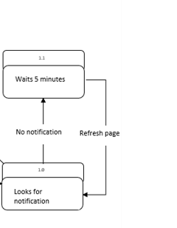After researching the business, it has come to my attention that the manager is the only member of staff, with access to the company account used for online order tracking. Furthermore, the manager manually refreshes the webpage checking for any new orders which seems to be roughly every five minutes. This is deemed inefficient as the manager could be assisting elsewhere it is not needed for the manager to manually refresh the page as several solutions could resolve this. The simplest solution could be by having a notification system. Another solution could be to install a program that automatically refreshes the page or for the order to be displayed on a screen for the kitchen staff to see, after payment is approved this (Patel, December, 2015)“will allow restaurants to increase the scope of business by reducing the labour cost involved.” As there is no need for the manager to manually refresh the page if this is implemented.

As shown herein (Figure 1). The progress loops take a large amount of time and effort from the manager, which could be used elsewhere alongside this. The manager is highly skilled and has a lot of experience and knowledge inside the kitchen, but refuses to assist inside there, regardless of the situation. This could be crucial to the quality of a customer’s meal. As managers, they should be flexible and be able to adapt to any situation this is supported by, (Drucker, 2019)“An **effective leader** focuses on productivity in various layers such as motivation, teamwork, communication and objectives.”

Figure Manager Loop

### Data flow diagram for online order

Figure DFD of Online Ordering

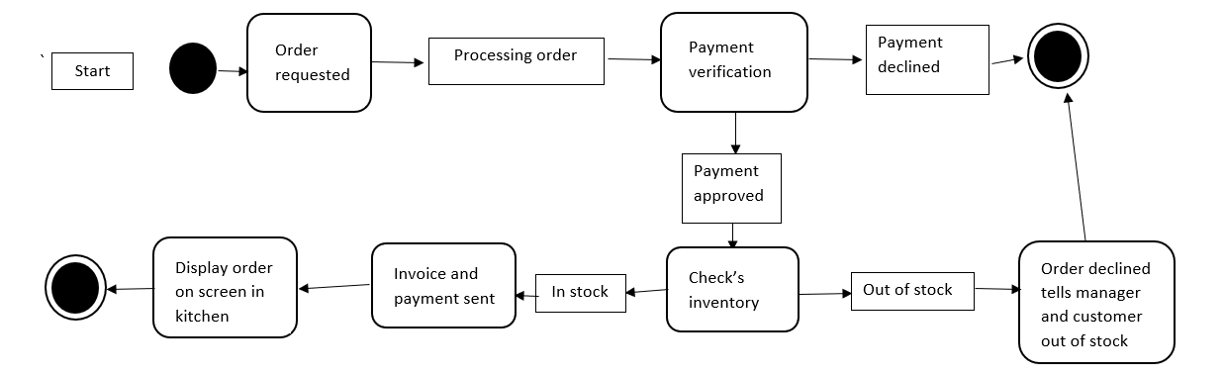

Figure State machine online order system

## Ordering by Phone

Rotherham Kebabs does not have a system to put callers on hold or a queue when their lines are busy. Studies have shown, it’s more effective to have queues or a system to go on hold or request a call back. When a line is busy when trying to order a meal, it can be infuriating. This can cause stress to staff and loss of customers. Therefore, it is important to improve the business to receive more orders. A queuing system needs to be implemented (Figure4) to support this a study conducted by [Software Advice](http://www.softwareadvice.com/) in 2014 that had found that (Toporek, 2014)“63% of respondents prefer a callback option instead of waiting on hold” This could be an efficient way of maintaining a professional standing with customers.

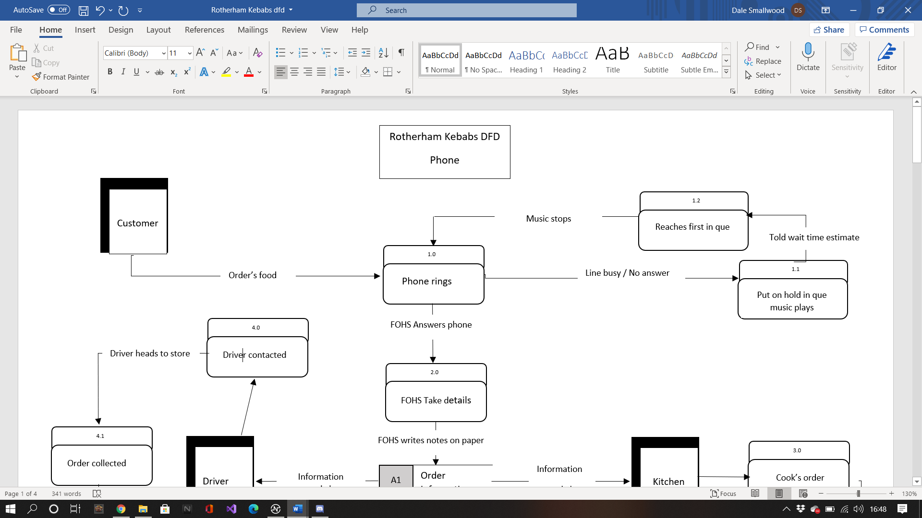

Figure On-Phone Improvement

### Data flow diagram on the phone ordering

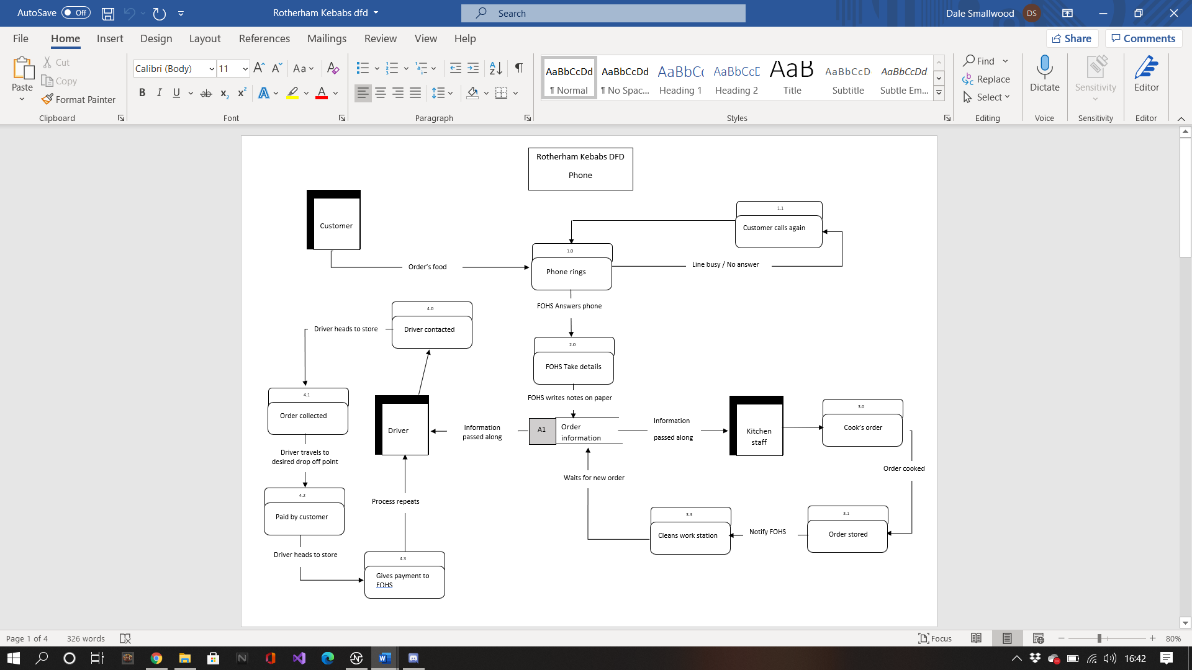

Figure on Phone DFD

## Instore ordering

Instore ordering can be improved by having larger signs displaying the food available. There could also be issues where the staff are not able to serve the customer in-store as they might be busy serving customers via phone orders. Referring to putting on hold or ques, can aid this issue. Another solution would be the manager assisting the front of house staff by serving a customer. In-store checkouts can also be a great solution to this. according to (LS Retail, 2020) “not only are self-service kiosks delivering on consumer desire for ultimate convenience, but they’re also altering behaviour too.” This can be extremely beneficial for customer satisfaction as well as a business perspective as it has been shown that (LS Retail, 2020)“self-ordering has been demonstrated to boost sales by **increasing the average order size per customer**, while at the same time lowering costs in the restaurant by improving efficiency.“ and another major improvement having a self-checkout system would be that it minimizes order issues, (qsrmagazine, 2017)“order errors are still inevitable, especially with more customization options. A visual recap of a customer’s order puts the responsibility on the customer, increasing accuracy.

” It is also good business practice to be polite and patient when under pressure with both the customer and the fellow members of staff.

### Data flow diagram of in-store ordering

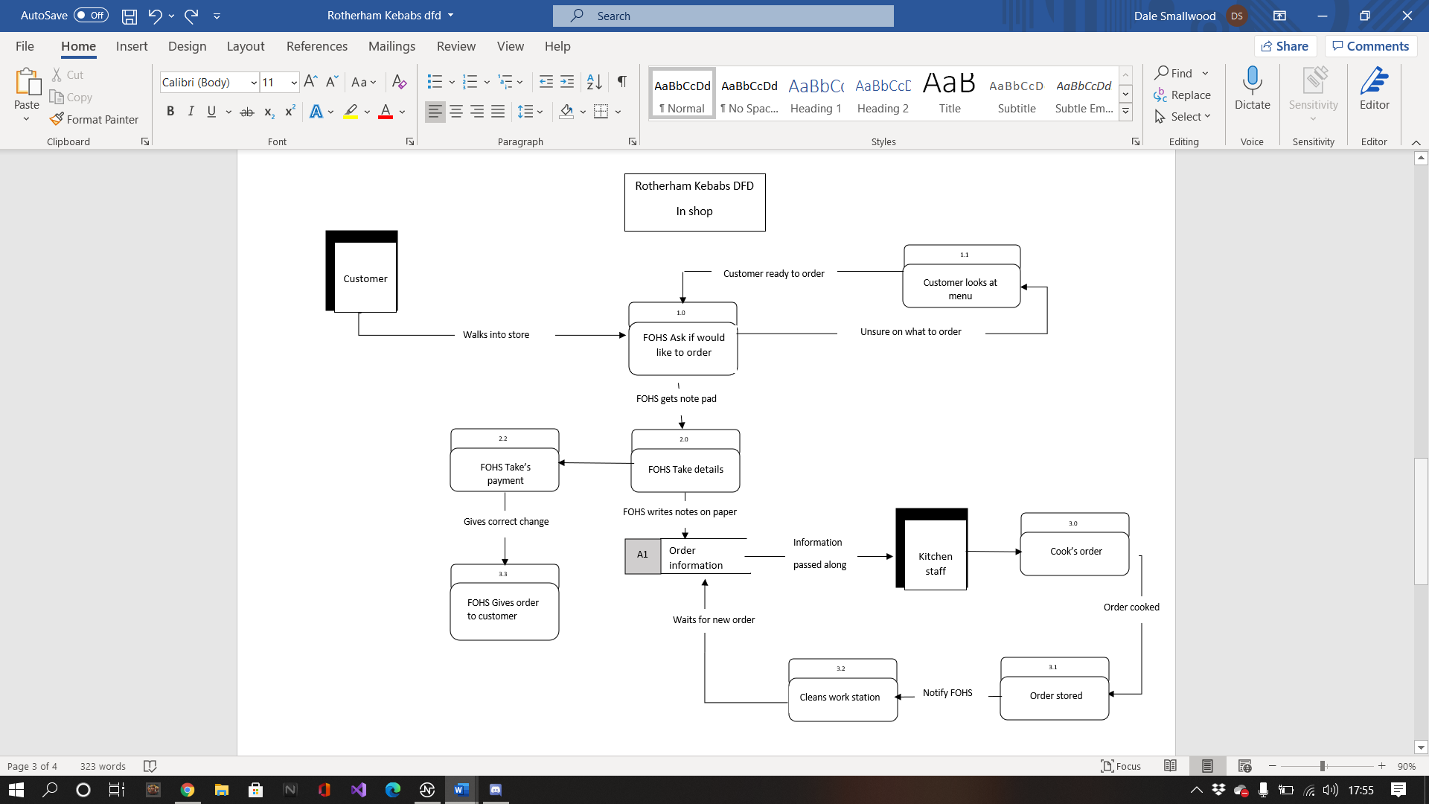

Figure In shop DFD

# Importance of system modelling

System modelling is key when displaying different outlooks of a business to gauge what is the most effective and cost-efficient route, each model represents a different meaning and understanding. Using models assists the analyst in having a greater understanding of the functionality of the system this can explain the process from different points of view.

The most crucial and commonly used diagrams are known as.

### Activity diagrams

These show how an activity would be carried out through a detailed explanation.

(Bell, 2003)“activity diagrams can be used independently of use cases for modelling a business-level function, such as buying a concert ticket or registering for a college class.”

### Use case diagrams

A case diagram displays the expected result and how it will be achieved. This is done by text as well as a visual diagram. This aids in making a design from the customer’s perspective. This is normally a basic summary and not overly complex.

### Sequence diagrams

A sequence diagram is the interactions between systems meaning that this is useful for collaborative businesses and helps them to understand an already functioning process. The interactions display how and in what order those interactions were made.

### State diagrams

State machine diagrams are made up of transitions and events. They are used to display how a system functions and are extremely important when explaining the process of the system, for example, a cash machine’s state diagram would consist of the system becoming active once the card is inserted and depending on the options selected its process could be completed as it displays the behaviour of the sequence.

## Reduction of waste

By using different types of diagrams, it is possible to decipher what processes and events waste time and energy. Which could lead to losing additional profits, that is why it is key to perform an analysis of a business. Sometimes the solution may not be initially cost-efficient but over a long period, it may become viable such as automation.

## Efficiency

Automation is proven to be efficient over long periods as it is reliable and responsive which is why many fast-food chains have taken on board this approach, (Haugland, 2017) “Automation also alleviates stress, because things will be done, and you don’t have to worry about remembering to do them.”

# what is a Crud analysis?

CRUD is the abbreviation of Create, Read, Update, and Delete. This is displayed on a table, normally displayed on the left-hand side, is the process or operations and across the top of the table would be entities as shown in (figure7). This displays how each entity corresponds with the other. A CRUD analysis is normally used when creating a website application as it assists in the design and framework.

## Crud analysis of Rotherham kebabs

Figure Rotherham Kebabs CRUD

# Normalization

(Li, 2019)“Normalization is a technique for organizing data in a database. A database must be normalized to minimize redundancy” An example of redundancy in Rotherham Kebab’s database would be as shown below in (figure8).

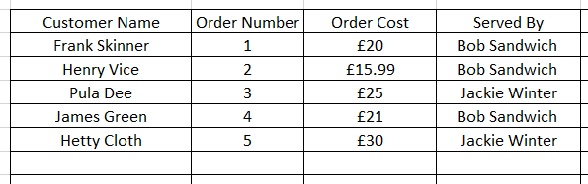

Figure Example of redundancy

Some of the information is repeated during each order by the member of staff on the cash register to be exact this data is unnecessary and is increasing the size of the database. To combat this, the information only needs to be displayed when logging into the register and logging out. This will reduce issues. Without this, it leads to an insertion anomaly, or if another staff member is also using the cash register at the same time it could lead to an updating anomaly, as it would be constantly changing information for each sale. Normalization will amend these problems by making these tables two separate tables, saving information separately. One for the items ordered and price and one for staff on register or who served the customer. Another way to resolve this might be just inputting the initials of the staff member instead of a full name saving on data size, this helps with other issues down the line such as inserting new information deleting existing information or updating it.

# What are Entity relationship diagrams?

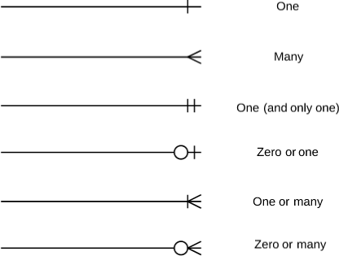Entity relationship diagrams (ERD) are normally built before creating a database to help and assist engineers understand how the database interacts with all stored information. This is done visually, displaying multiple elements and how they work together as shown below in (Figure9). This is known as ERD Cardinality. This explains what, each symbol refers to and how the entity and attribute interact with each other, continuing inside (Figure 10) is an ERD of the Rotherham Kebabs order process.

Figure LucidChart (2020) [ERD Cardinality] https://www.lucidchart.com/pages/ER-diagram-symbols-and-meaning

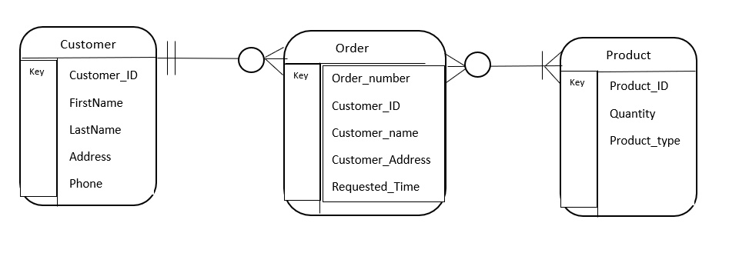

Figure Entity Relationship Online Order System

# Doncaster DIY

After looking at Rotherham Kebabs, research has shown that their business needed drastically improving so solutions were provided, but when comparing Rotherham Kebabs to Doncaster DIY, Doncaster DIY is a more efficient and cost-efficient business. This is because of multiple excellent business practices. Inside this section, their systems and processes are explained in detail as, to why they are more efficient and cost-effective.

## Online

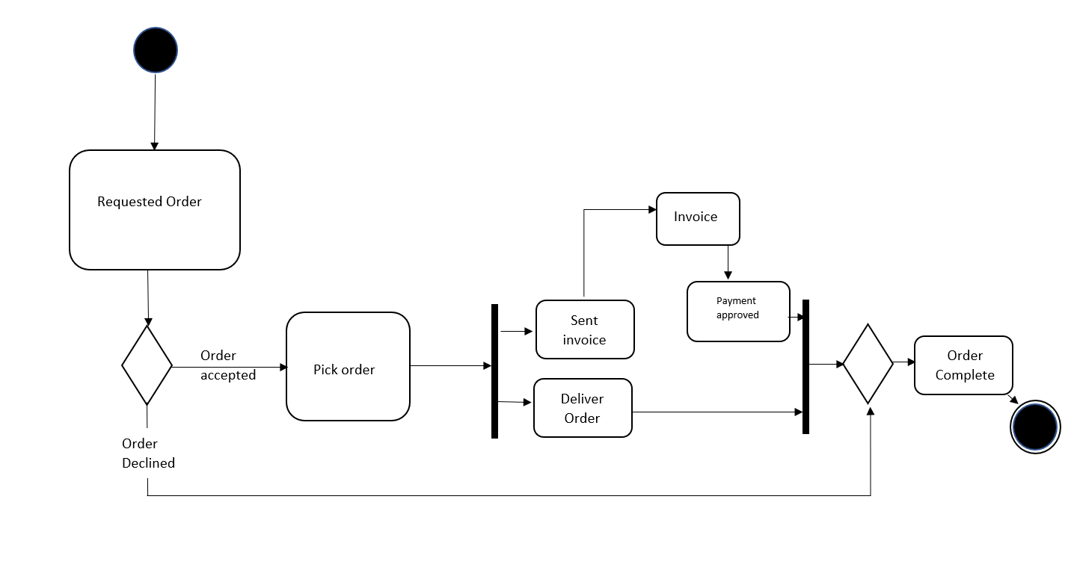At Doncaster DIY, the manager can multitask effectively because of the cut of points for requesting an item. This is stored in a database that the manager checks afternoon instead of waiting for an individual order or notification. Therefore the manager can help out elsewhere, unlike Rotherham Kebabs. The manager also overlooks the online website just in case the system was to go down, it can be dealt with as soon as possible. This was achieved by working alongside a third-party company that receives required items needed the next day for restocking as shown in (figure11).

Figure Activity Diagram

## Phone Call

Continuing with the manager’s role as the manager works in the office in the back of the store he can answer the telephone and speak to other customers who may be requesting an order or if an item is in store this information is added to the database throughout the day until cut off point (if the item is not in stock) comparing the manager of Doncaster DIY to Rotherham kebabs, The DIY store manager is a lot more efficient and outgoing as they cannot only just multitask but do it efficiently.

## In-Store

As stated in the company overview, there are three members of staff on-site during open hours. This is cost-efficient as each member of staff is available to do multiple tasks. Having a floor walker where customers can ask questions about products is an excellent way to gain knowledge on what current items are popular as well as overlooking the store for shoplifters and restocking items if needed. As explained in the overview after closing the store to the public, a stock count is taken place. It is a great business practice to do this as the company can spot if items are either out of stock, are popular or have been stolen, as the information gathered can be compared by the cash register history by the members of staff after the stock count is completed. The information is then passed along to the third-party company they work alongside as the items are ordered picked up in a warehouse overnight and delivered the next day. This connects to the online ordering process again being cost-efficient.

# Bibliography

Bell, D. (2003). *UML basics Part II: The activity diagram*. Retrieved from The Rational: http://www.bowdoin.edu/~allen/courses/cs260/readings/UMLactivitydiagrams.pdf

Drucker, P. (2019, September 13th). *Efficient Management vs. Effective Leadership*. Retrieved from Norhart: https://www.norhart.com/blog/2019/09/13/efficient-management-vs-effective-leadership/

Haugland, T. (2017, February 13th). *Increasing efficiency through automation - The role of the three 'R's*. Retrieved from N-able: https://www.solarwindsmsp.com/blog/increasing-efficiency-through-automation-role-three-rs

Li, L. (2019, July 2nd). *Database Normalization Explained*. Retrieved from Towards Data Science: https://towardsdatascience.com/database-normalization-explained-53e60a494495

LS Retail. (2020, July 22nd). *retail*. Retrieved from How the self-service trend is transforming restaurants: https://www.lsretail.com/blog/how-the-self-service-trend-is-transforming-restaurants

LucidChart. (2020). *Entity-Relationship Diagram Symbols and Notation.* Retrieved April 2nd, 2021, from Lucidchart: https://www.lucidchart.com/pages/ER-diagram-symbols-and-meaning

Patel, M. (December 2015). *Online Food Order System for Restaurants.* Grand Valley State University: ScholarWorks Citation. Retrieved from https://scholarworks.gvsu.edu/cgi/viewcontent.cgi?article=1222&context=cistechlib

QSR magazine. (2017, November). *6 Key Ways Self-Serve Kiosks Can Boost Your Sales*. Retrieved from QSR: https://www.qsrmagazine.com/outside-insights/6-key-ways-self-serve-kiosks-can-boost-your-sales

Toporek, A. (2014, June 12th). *DO CUSTOMERS PREFER A CALL BACK? THIS STUDY SAYS YES*. Retrieved from customersthatstick: https://customersthatstick.com/blog/customer-service-techniques/do-customers-prefer-a-call-back-this-study-says-yes/

# Appendix/Appendices

**Rotherham Kebabs**

Rotherham Kebabs is a takeaway kebab shop based in Rotherham. There is a manager who employs two front of house staff (FOHS) who receive the orders and two kitchen staff (KS) responsible for doing the cooking (and also maintaining the cooking area – washing up, wiping round, etc). There are several self-employed drivers (SED) who work with the kebab shop as well to do deliveries. Many of these drivers are associated with multiple takeaways and will combine orders – taking, for example, a kebab from Rotherham Kebabs and a pizza from another shop to two different addresses if those addresses are close. The manager works the front of the house and is capable of doing any task requiring FOHS but began in the kitchen and is also capable of performing any KS task, though they do not like that work and as such never help in the kitchen.

Food

Receiving Orders

They receive orders from members of the public through three different channels – phone, internet portal and in-shop orders.

Phone

A member of the public rings the store and the phone is answered by whichever FOHS is available at the time. The order is written down on a notebook page (each FOHS has its notebook) along with the delivery details (collection or delivery). That notebook page is given to the physically nearest KS who will add it to their pile of orders to prepare (each KS maintains their list of orders if one KS has no orders to prepare they spend their time cleaning, tidying or going on a break). The KS prepares the order and then places it in a keep-warm oven along with the notebook page. There is no answerphone on the phone and if FOHS are busy then the phone often takes the lowest priority.

Internet

The manager has login details to a website through which customers can place orders – no one else has access. Periodically through the night, he will check that website. Any orders placed are printed out – one order per sheet, and given to the KS. KS treat these sheets the same as notebook pages. The shop gets fined for orders placed this way that do not get fulfilled in a given time which has made the manager check the website extremely regularly – most times it is checked there will be no orders placed.

In-Shop

A member of the public enters the shop and speaks to the nearest available FOHS. They take the order and write it down in their notebook and hand the page to KS. KS treat these the same as other notebook pages. The member of the public waits in the shop until their order is prepared, at busy times this can cause problems as the shop isn’t overly large.

Giving The Customer Their Food

As mentioned above, once KS have finished preparing an order they place it in a heated cabinet to keep it warm along with the paper containing the original order. When a FOHS has a moment they will look through the prepared food. Any for in-shop customers will be taken out and given to the customer, who then pays and leaves.

When a SED enters the store (there is no set schedule for this, they arrive when they are ready and want to) they look through the cabinet for any delivery meals. To maximise their return on each journey they will not necessarily take all that they find, instead choosing ones that are close together or that are close to orders they already have from other stores. They will choose the meals they want to deliver and talk to an available FOHS to calculate the cost(s). They will then go and deliver the food and charge the customer. Next time they are in the shop they will return the money they took for that delivery minus a percentage they keep for themselves. To encourage them to deliver internet orders quickly – as mentioned, the shop is fined for late deliveries for these orders – the commission for internet orders is higher than for phone orders.

The manager suspects that some money is going missing at some point in the delivery process, but is not sure precisely how.

Ordering Stock

At the end of each night, the manager checks what stock remains in the shop and makes a note of it. The next day he visits wholesalers and orders what is needed. As he has been running the shop for a while he is aware of which nights are busy and how much is needed for each item for a given night. If, on a night, they are unable to fulfil an order delivered by phone or in-person they simply inform the customer that that item is unavailable – the customer either orders another item or the order is lost. In the case of internet orders, the manager can suggest a substitution through the online system which the customer either accepts or rejects – no fine is incurred if the customer rejects the suggestion.

Paying Staff

SED take their cut of any delivery they make and aren’t the responsibility of Rotherham Kebabs. Every Friday morning the manager produces payslips for the FOHS and KS – these are paid each Friday (or when he next sees them). As there is no formal clocking-in or out procedure, everyone is paid for the same shift regardless of whether they arrived late, stayed late, etc and the manager does his best to remember who was working each day that week.

HMRC, Food Hygiene Certification and Licenses

There are assorted legal requirements to running a business and a food preparation one specifically. You **may** choose to look into these areas as well. You do not have to.

**Doncaster DIY**

Doncaster DIY is a multifunctional hardware store that contains an online ordering system for products to be collected instore the following day if ordered before noon (deposit required) This is because the received orders are passed across to a third-party company, that order picks the required equipment, to be received the following morning.

Before the store opens at 9 am, a member of staff participates in a regular stock count to see which stock they are low on and if there are less than five of a specific item. it is then added to the order list. After the stock count, A member of staff prepares to open the store around 9:30 am. There are normally 3 members of staff on site whilst the store is open to the public. A cashier that mans the cash register, A floor walker that restocks items after purchases that can also be approached to ask for help or questions and finally a manager who overlooks CCTV. Alongside keeping track of online orders, at the noon cut-off point, the manager also runs the telephone being able to take orders via mobile phone or let a customer know that the item is in stock this information is added to the database for the stock count.

At closing time 5 pm, a second stock count took place to keep track of what are the current popular items. If an item is popular, the stock held is drastically increased to 30 for the next week instead of 20. After this stock count, the store is deep cleaned for the next day.